# Pets

You need to add 20 things to this document. (Make sure to number them just as I did in the example.) It may be helpful to copy and paste this list and then fill it in as you go along. All image names must start with your location, e.g yellowstone_sunset.jpg unless you are using a link from the internet.

## Van Gogh

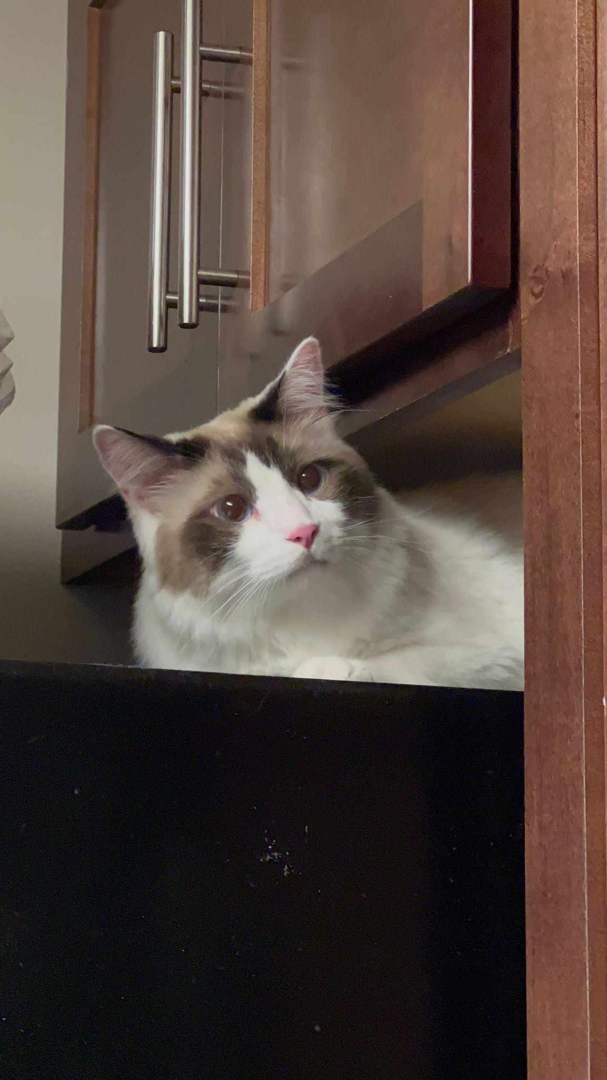

1. van_gogh_on_fridge.jpg
2. Ragdoll cat sitting on top of black fridge
3. Van Gogh is a three year old cat of mixed ragdoll and domestic shorthair breed. He was adopted when he was 7 months old. Van Gogh has been a people cat since he was young. He craves attention but needs alone time when he wants it. He is purely a masterpiece when his sapphire eyes staring at his human friends. He loves birds, rats, insects, and water from human mug..
4. Van Gogh is responsible for his household safety. But he gets scared when the vacuum machine wakes up. He tries his best to make defense but his beautiful fur coat gets messed up immediately when he gets too close. By the way, he likes his fur coat being brushed by himself. He bites when he does not get enough attention, but he always gets what he wants.
5. **Photo Gallery**
6. van_gogh_sleeping.jpg
7. Van Gogh sleeping on sofa while covering his eyes up with paws
8. van_gogh_sitting.jpg
9. Van Gogh sitting on coach
10. van_gogh_cactus_bed.jpg
11. Van gogh lying happily in his cactus cat bed with a wink
12. van_gogh_running.MOV
13. Van Gogh running towards camera for treats
14. **Likes – (Just write Likes)**
15. Biting his human
16. Chicken Breast
17. His catnip pillow
18. Chris Cheng